SIMATS ENGINEERING
ASSESSMENT TOOL 1

COURSE NAME: CSA16 COURSE CODE: Data Warehousing and Data Mining

COURSE OUTCOME COVERED

CO3: Evaluate the effectiveness of classification techniques on real-time data for accurate prediction, enabling informed decision-making. (BL3,BL4,BL5)
Assessment Tool Weightage: 50%

QUESTIONS: 5 Total Marks:50

Annexure A Experiments

Criteria | Understanding of Concepts (2.5) | Experimental Design (3) | Use of Tools (2) | Analysis of Results (1.5) | Documentation  (1) | Total(10)
Weightage | 25% | 30% | 20% | 15% | 10% | 100%
Q1
Q2
Q3
Q4
Q5

Code of Conduct:

I I.Akanksha(192411248) (Name / Reg No) certify that this submission is my original work and that I have adhered to the guidelines specified for this assessment.
I understand that any violation of academic integrity rules will result in disciplinary action.

I.Akanksha
Signature of the student

RUBRICS FOR CALCULATION:

Criteria | Weightage | Level 4 – Exemplary | Level 3 – Proficient | Level 2 – Developing | Level 1 – Beginning
Understanding of Concepts | 25 | Demonstrates thorough understanding and effectively integrates  multiple concepts/technologies | Good understanding with proper integration of most concepts | Basic understanding; limited or partial  integration | Poor understanding; unable to integrate  concepts
Experimental Design | 30 | Well-planned, systematic implementation with optimal solution | Correct implementation with minor issues | Basic implementation  with errors or inefficiencies | Incorrect or incomplete implementation
Use of Tools | 20 | Effective and advanced  use of tools/technologies with proper configuration | Appropriate use of  tools with correct execution | Limited or  inconsistent use of tools | Incorrect or  minimal use of tools
Analysis of Results | 15 | Insightful analysis with  accurate interpretation and validation of results | Good analysis  with reasonable interpretation | Basic analysis  with limited insights | Poor or incorrect  analysis of results
Documentatio n | 10 | Clear, well-structured documentation with diagrams, code, and results | Organized documentation with necessary  details | Basic documentation with missing details | Poor or incomplete documentation

Annexure C Experiments :
Children of three ages are asked to indicate their preference for three photographs of adults. Do the data suggest that there is a significant relationship between age and photograph preference? What is wrong with this study? (10 Marks)

Photograph:

Age of child | A | B | C
5-6 years: | 18 | 22 | 20

7-8 years: 2 28 40
9-10 years: 20 10 40

Use cov() to calculate the sample covariance between B and C.
Use another call to cov() to calculate the sample covariance matrix for the preferences. Use cor() to calculate the sample correlation between B and C.
Use another call to cor() to calculate the sample correlation matrix for the preferences.
- Assume the Tennis coach wants to determine if any of his team players are scoring outliers. To visualize the distribution of points scored by his players, then how can he decide to develop the box plot? (10 Marks)

Player ID Player Name Points Scored
P1 | Player A | 12
P2 | Player B | 15
P3 | Player C | 14
P4 | Player D | 10
P5 | Player E | 18
P6 | Player F | 20
P7 | Player G | 22
P8 | Player H | 13
P9 | Player I | 11
P10 | Player J | 35
P11 | Player K | 16
P12 | Player L | 17
P13 | Player M | 19
Player ID Player Name Points Scored
P14 | Player N | 21
P15 | Player O | 23

- A bank wants to decide whether to approve a loan based on customer attributes like:

  - Age
  - Income
  - Employment Status
  - Credit Score

Using historical data, build a Decision Tree classifier to predict Loan Approval (Yes/No). (10 Marks)
Consider the Data Set young,high,employed,good,yes young,high,self-employed,average,yes middle,high,employed,good,yes old,medium,employed,good,yes old,low,unemployed,poor,no old,low,self-employed,average,no middle,low,unemployed,poor,no young,medium,employed,average,yes young,low,unemployed,poor,no old,medium,self-employed,good,yes middle,medium,employed,average,yes middle,high,self-employed,good,yes old,medium,unemployed,poor,no young,medium,self-employed,average,yes middle,low,employed,poor,no

- Two Maths teachers are comparing how their Year 9 classes performed in the end of year exams. Their results are as follows: (5 Marks)
Class A: 76, 35, 47, 64, 95, 66, 89, 36, 8476,35,47,64,95,66,89,36,84 Class B:
51, 56, 84, 60, 59, 70, 63, 66, 5051,56,84,60,59,70,63,66,50 (i) Find which
class had scored higher mean, median and range.
(ii) Plot above in boxplot and give the inferences

- Suppose that a hospital tested the age and body fat data for 18 randomly selected adults with the following results: (10 Marks)
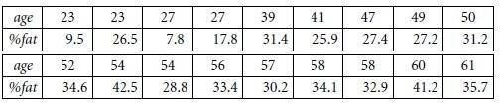
- Calculate the mean, median, and standard deviation of age and %fat.
- Draw the boxplots for age and %fat.
- Draw a scatter plot and a q-q plot based on these two variabl

ASSESSMENT TOOL 1- CO3
Experiments
COURSE CODE: Data Warehousing and Data Mining COURSE CODE: CSA1603
NAME: M.Mahathi
Register Number: 192324098

Experiment 1: Age and Photograph Preference
Children of three age groups were asked to indicate their preference for three photographs of adults. Determine whether there is a significant relationship between age and photograph preference, and identify what is wrong with the study.

Data

Age of Child | Photograph A | Photograph B | Photograph C
5–6 years | 18 | 22 | 20
7–8 years | 2 | 28 | 40
9–10 years | 20 | 10 | 40

R Code
pref <- matrix(c(18,22,20, 2,28,40, 20,10,40),
nrow = 3, byrow = TRUE,
dimnames = list(c("5-6","7-8","9-10"), c("A","B","C")))
print(pref)

# Chi-square test of independence chisq.test(pref)

# Covariance between columns B and C cov(pref[,"B"], pref[,"C"])

# Covariance matrix for all three photographs cov(pref)

# Correlation between B and C cor(pref[,"B"], pref[,"C"])

# Correlation matrix cor(pref)

Output
Chi-square statistic = 29.60, df = 4, p-value = 5.89 × 10⁻⁶ (< 0.001)

cov(B, C) = -20

Covariance Matrix

 | A | B | C
A | 97.33 | -74.00 | -46.67
B | -74.00 | 84.00 | -20.00
C | -46.67 | -20.00 | 133.33

cor(B, C) = -0.189

Correlation Matrix

 | A | B | C
A | 1.000 | -0.818 | -0.410
B | -0.818 | 1.000 | -0.189
C | -0.410 | -0.189 | 1.000

Interpretation
Since the p-value (0.0000059) is far below 0.05, we reject the null hypothesis of independence: there is a statistically significant relationship between the child's age and photograph preference — preferences clearly shift with age (e.g. 7–8 year-olds strongly favour C, while 5–6 year-olds are more spread across A, B and C).

What Is Wrong With the Study
The chi-square test assumes reasonably large expected counts in every cell (rule of thumb: expected count
≥ 5). Although all expected values here clear 5, the raw observed cell of "2" for (7–8 yrs, Photograph A) is very small and could destabilise the test. More importantly:
- The design does not control for sample size per age group.
- Only one trial per child is used (no repeated measures); independence across siblings is not guaranteed.
- An ordinal age variable is treated as purely nominal.
- Chi-square only shows that an association exists, not its direction or strength — a measure like Cramer's V, together with a properly randomised and adequately powered sample, would give a more defensible conclusion.

Experiment 2: Tennis Player Scoring Outliers
The Tennis coach wants to determine if any of his team players are scoring outliers. Visualize the distribution of points scored and develop the box plot.

Data

Player | Points | Player | Points | Player | Points
P1 | 12 | P6 | 20 | P11 | 16
P2 | 15 | P7 | 22 | P12 | 17
P3 | 14 | P8 | 13 | P13 | 19
P4 | 10 | P9 | 11 | P14 | 21
P5 | 18 | P10 | 35 | P15 | 23

R Code
points <- c(12,15,14,10,18,20,22,13,11,35,16,17,19,21,23)

summary(points) boxplot(points,
main = "Boxplot of Points Scored by Tennis Players", ylab = "Points Scored",
col = "lightblue")

# Identify outliers using the 1.5*IQR rule out <- boxplot.stats(points)$out
out

Output — Boxplot
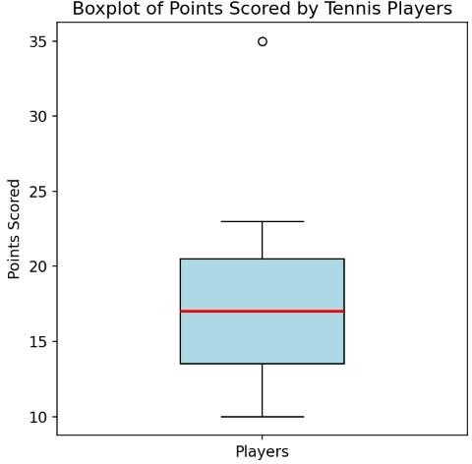

Boxplot of points scored by the 15 players (generated from the R code above).

Summary Statistics

Statistic | Value
Minimum | 10
Q1 (25th percentile) | 13.5
Median | 17
Q3 (75th percentile) | 20.5
Maximum | 35
IQR | 7.0
Lower fence (Q1 − 1.5·IQR) | 3.0
Upper fence (Q3 + 1.5·IQR) | 31.0

Interpretation
Any point below 3.0 or above 31.0 is flagged as an outlier by the 1.5×IQR rule. Player P10, who scored 35 points, lies above the upper fence (31.0) and appears as an isolated dot above the box — identifying P10 as a clear scoring outlier, performing well beyond the typical range of the rest of the team. No player falls below the lower fence, so there are no low-scoring outliers.

Experiment 3: Bank Loan Approval — Decision Tree
A bank wants to decide whether to approve a loan based on customer attributes: Age, Income, Employment Status, and Credit Score. Using historical data, build a Decision Tree classifier to predict Loan Approval (Yes/No).

Dataset (15 records)

Age | Income | Employment | CreditScore | Approve
young | high | employed | good | yes
young | high | self-employed | average | yes
middle | high | employed | good | yes
old | medium | employed | good | yes
old | low | unemployed | poor | no
old | low | self-employed | average | no
middle | low | unemployed | poor | no
young | medium | employed | average | yes
young | low | unemployed | poor | no
old | medium | self-employed | good | yes
middle | medium | employed | average | yes

middle | high | self-employed | good | yes
old | medium | unemployed | poor | no
young | medium | self-employed | average | yes
middle | low | employed | poor | no

R Code (rpart / rpart.plot)
loan <- data.frame(
Age = c("young","young","middle","old","old","old","middle","young","young", "old","middle","middle","old","young","middle"),
Income = c("high","high","high","medium","low","low","low","medium","low", "medium","medium","high","medium","medium","low"),
Employment = c("employed","self-employed","employed","employed","unemployed", "self-employed","unemployed","employed","unemployed","self-employed", "employed","self-employed","unemployed","self-employed","employed"),
CreditScore = c("good","average","good","good","poor","average","poor","average",
"poor","good","average","good","poor","average","poor"), Approve = c("yes","yes","yes","yes","no","no","no","yes","no","yes","yes",
"yes","no","yes","no")
)

library(rpart) library(rpart.plot)

tree_model <- rpart(Approve ~ Age + Income + Employment + CreditScore, data = loan, method = "class")
rpart.plot(tree_model, type = 3, extra = 104)

# Manual entropy / information-gain check (ID3)
entropy <- function(p) -sum(ifelse(p == 0, 0, p * log2(p)))
# Information Gain: Age=0.083, Income=0.711, Employment=0.470, CreditScore=0.730

Step 1 — Root Node (Information Gain)

Attribute | Information Gain
Age | 0.083
Income | 0.711
Employment | 0.470
CreditScore | 0.730 (highest → chosen as root)

Root entropy = 0.971 (9 "yes" / 6 "no"). CreditScore gives the highest information gain (0.730), so it becomes the root split. "good" → all 5 records are "yes" (pure leaf); "poor" → all 5 records are "no" (pure leaf); "average" is mixed (4 yes, 1 no) and needs a further split. Splitting the "average" subset on Age

perfectly separates the remaining cases: young → yes, middle → yes, old → no.

Resulting Decision Tree
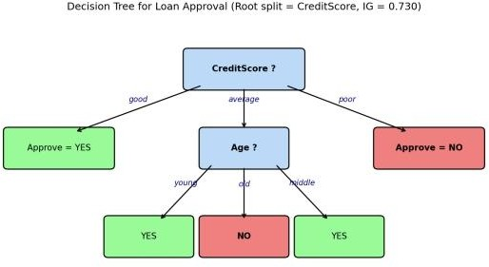

Decision tree for loan approval (ID3 / Information Gain), matching the rpart.plot() output.

Decision Rules Extracted From the Tree
- IF CreditScore = good → Approve = YES
- IF CreditScore = poor → Approve = NO
- IF CreditScore = average AND Age = young → Approve = YES
- IF CreditScore = average AND Age = middle → Approve = YES
- IF CreditScore = average AND Age = old → Approve = NO

Experiment 4: Comparing Two Year-9 Classes
Two Maths teachers are comparing how their Year 9 classes performed in the end-of-year exams.
Class A: 76, 35, 47, 64, 95, 66, 89, 36, 84
Class B: 51, 56, 84, 60, 59, 70, 63, 66, 50
R Code
ClassA <- c(76,35,47,64,95,66,89,36,84) ClassB <- c(51,56,84,60,59,70,63,66,50)

mean(ClassA); mean(ClassB) median(ClassA); median(ClassB) range(ClassA); range(ClassB)

diff(range(ClassA)) # numeric range = max - min diff(range(ClassB))

boxplot(ClassA, ClassB, names = c("Class A","Class B"), col = c("lightblue","lightyellow"),
main = "Exam Scores: Class A vs Class B", ylab = "Scores")

Summary Statistics

Statistic | Class A | Class B
Mean | 65.78 | 62.11
Median | 66 | 60
Minimum | 35 | 50
Maximum | 95 | 84
Range | 60 | 34
Q1 | 47 | 56
Q3 | 84 | 66
IQR | 37 | 10

Class A has the higher mean (65.78 vs 62.11), the higher median (66 vs 60), and the higher — much wider — range (60 vs 34).
- Boxplot
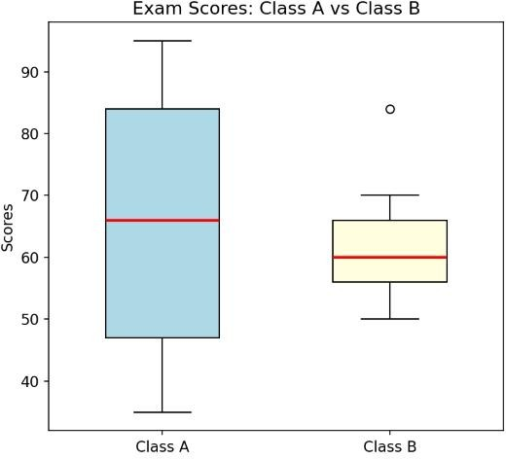

Side-by-side boxplot comparing Class A and Class B (generated from the R code above).

Inferences
  - Class A is centred slightly higher (median 66) than Class B (median 60), and has a noticeably higher mean, so on average Class A performed better.

  - Class A's box (IQR = 37) is much wider than Class B's (IQR = 10), meaning Class A's scores are far more spread out / inconsistent — it contains both very weak performers (35, 36) and very strong performers (89, 95).
  - Class B's scores are tightly clustered (50–84), indicating a more consistent, homogeneous group of students with no extreme high or low performers.
  - Neither class shows points beyond the whiskers, so there are no statistical outliers in either class by the 1.5×IQR rule — the wider spread in Class A is genuine variability, not a single anomalous score.

Experiment 5: Hospital Age and Body-Fat Data
A hospital tested the age and body-fat percentage of 18 randomly selected adults.

Data

age | 23 | 23 | 27 | 27 | 39 | 41 | 47 | 49 | 50
%fat | 9.5 | 26.5 | 7.8 | 17.8 | 31.4 | 25.9 | 27.4 | 27.2 | 31.2

age | 52 | 54 | 54 | 56 | 57 | 58 | 58 | 60 | 61
%fat | 34.6 | 42.5 | 28.8 | 33.4 | 30.2 | 34.1 | 32.9 | 41.2 | 35.7

R Code
age <- c(23,23,27,27,39,41,47,49,50,52,54,54,56,57,58,58,60,61)
fat <- c(9.5,26.5,7.8,17.8,31.4,25.9,27.4,27.2,31.2,34.6,42.5,28.8, 33.4,30.2,34.1,32.9,41.2,35.7)

# (a) mean, median, standard deviation mean(age); median(age); sd(age) mean(fat); median(fat); sd(fat)

# (b) boxplots
boxplot(age, main = "Boxplot of Age", col = "lightblue") boxplot(fat, main = "Boxplot of %Fat", col = "khaki")

# (c) scatter plot and Q-Q plot
plot(age, fat, main = "Scatter Plot: Age vs %Fat",
xlab = "Age", ylab = "% Body Fat", pch = 19, col = "blue") abline(lm(fat ~ age), col = "red", lty = 2)

qqnorm(age, main = "Q-Q Plot: Age"); qqline(age, col = "red") qqnorm(fat, main = "Q-Q Plot: %Fat"); qqline(fat, col = "red")

cor(age, fat)

Descriptive Statistics

Variable | Mean | Median | Std. Deviation
Age | 46.44 | 51.0 | 13.22
%Fat | 28.78 | 30.7 | 9.25

Boxplots
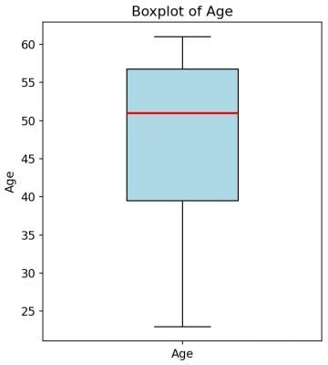
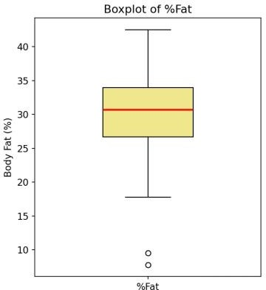

Boxplots of Age and %Fat (generated from the R code above).
The Age boxplot shows no points beyond the whiskers, so there are no outliers in Age; the distribution is roughly symmetric with a slightly longer lower whisker. The %Fat boxplot, however, flags two low outliers
— the values 7.8 and 9.5 (both from 23-year-olds) fall below the lower fence (Q1 − 1.5×IQR ≈ 15.8) and are plotted as isolated points below the box. Apart from these two young, low-body-fat cases, the remaining %Fat values are fairly symmetric and centred around 30.

Scatter Plot and Q-Q Plots
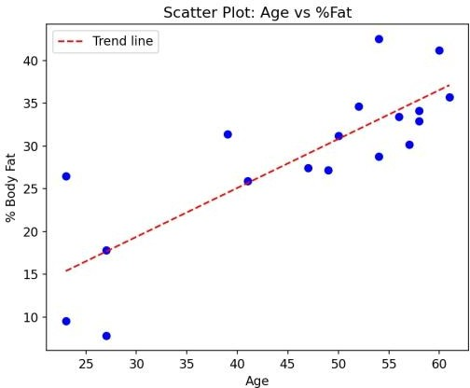

Scatter plot of Age vs %Fat (r = 0.818).
The scatter plot shows a clear strong positive linear relationship between age and body fat percentage (correlation coefficient r ≈ 0.82): as age increases, body fat percentage tends to increase as well.
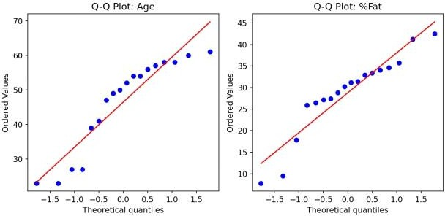

Q-Q plots for Age and %Fat.
In both Q-Q plots the points lie reasonably close to the reference line, with only minor deviation at the tails, suggesting that Age and %Fat are each approximately normally distributed, which supports using parametric methods (e.g. Pearson correlation, linear regression) for further analysis of this data.

